 

*MTPG Limited*

(A Govt. of India Enterprise)

DADRI

 tzsql / Ref. No.



TO WHOM SO EVER IT MAY CONCERN

‘I i ce NTPC Purchase Order No 5500029612-056—1011

\/\‹’e leave placed purchase order of turnkey project of electrical, civil and mechanics!

\ er!acen eiJt of hydraulic coupling with flexible coupling and VFD) for 6.6kV ID Can ap licaticn in our Unit#2 at NCPS, Dadri Plant on Ethan Power Pvt Ltd

Tf+? was a complete turn-key project for 2 Nos. ID Fan motors, i.e. 2 x 1400kW 6 Ck\\* inclunusg Civil, electrical, mechanical and other associated work with SITC responsibility on Ethan Power Private Limited.

One MVD system was commissioned in Aug' 2019 and second was commissioned in Oct’ 2019 Complete system has been supplied, erected and commissioned within contract timeLnes.

We are pleased to inform that complete system including ABB make VFD supplied and commissioned by Ethan Power Pvt Ltd is working satisfactorily and meeting our expectations.

We have achieved maximum benefits of energy savings by replacing hydraulic coupling with flexible coupling and VFD.

Ethan Power is having the capability to evaluate energy saving, engineering, commission and support for turn-key project, and we have received good sales and after sales support from Ethan Power.

With the local support and competency available from Ethan Power, we hope that we will be able to maintain complete system smoothly and derive best benefits.

For NTPC Ltd Thanking you

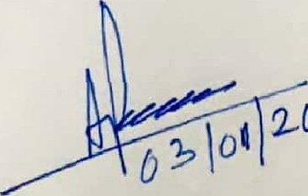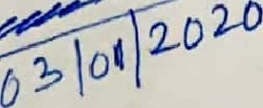

A. K. PRAMANlK

° • ° M°T

Addl. GenemtMcnmgar(1&VOalV)

Lm 7NTPCLtd-Dadn

Natbnal capital Power Satbn, p, B h U 201



91-120•2672330

284 9t 120 2$72330



91-11-6416 135

Scanned by CamScanner